8th September 2023
Dear parents

As we have started a new school year, I wanted to take the opportunity to remind you about attendance expectations within our school and The Constellation Trust.
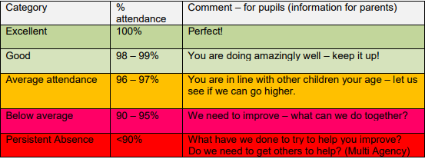

As a school, we would encourage all children to attend school every day (or as close as possible to this.) We know there may be exceptional circumstances such as a genuine illness, medical appointments or emergencies however these should be rare.
Please note that holidays in term time will not be authorised except in exceptional circumstances.
Our Trust Attendance policy is attached to this email.
Before half term we will be analysing attendance across the school and, as per our policy, we may contact any families who have an attendance figure which is concerning. We hope you will work with us to improve attendance if required.

Please remember:

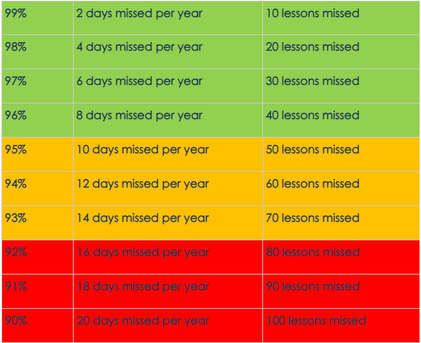

Please also remember that school now begins at 8.45am and finishes at 3.15pm and children should be prompt to school as teaching begins immediately..

Yours sincerely
A Saunders
Mrs A Saunders

