Working together for your children

Mental Health and Emotional Wellbeing Policy

Date written: October 2023

To be reviewed: October 2025

This policy was written in consultation with staff, pupils, and parents and Local Advisory Board members.
At Victoria Dock Primary, we are committed to supporting the emotional health and wellbeing of our whole school community.
We have a supportive and caring ethos and our approach is respectful and kind, where each individual and contribution is valued.
At our school, we know that everyone experiences life challenges that can make us vulnerable and at times, anyone may need additional emotional support. We take the view that positive mental health is everybody’s business and that we all have a role to play.
At our school we:

- help children to understand their emotions and feelings better
- help children feel comfortable sharing any concerns or worries
- help children socially to form and maintain relationships.
- promote self esteem and ensure children know that they count.
- encourage children to be confident and know it is OK to be themselves’
- help children to develop emotional resilience and to manage setbacks.

We promote a mentally healthy environment through:

- Promoting our school values and encouraging a sense of belonging.
- Promoting pupil voice and opportunities to participate in decision-making
- Celebrating academic and non-academic achievements
- Providing opportunities to develop a sense of worth through taking responsibility for themselves and others
- Providing opportunities to reflect.
- Access to appropriate support that meets their needs We pursue our aims through:
  - Universal, whole school approaches
  - Support for pupils going through recent difficulties including bereavement.
  - Specialised, targeted approaches aimed at pupils with more complex or long term difficulties .

Scope

This policy should be read in conjunction with our Medical policy and our SEND policy in cases where pupils' mental health needs overlap with these. This policy should also be read in conjunction with policies for Behaviour and Anti-bullying, and PSHE policies. It should also sit alongside child protection procedures.

Lead Members of Staff

Whilst all staff have a responsibility to promote the mental health of students, staff with a specific, relevant remit include:
  - Louise Taylor - Senior Mental Health Lead/Deputy Designated Safeguarding Lead
  - Nicky Leach - Designated Safeguarding Lead
  - Antonia Saunders - Head Teacher/ Deputy Designated Safeguarding Lead
  - Mrs Donna Haggar - Emotional Literacy Support Assistant
  - Darran Walster - Mental Health First Aider

Teaching about Mental Health

The skills, knowledge and understanding needed by our students to keep themselves mentally healthy and safe are included as part of our developmental PSHE curriculum delivered through our Jigsaw Programme.
The specific content of lessons will be determined by the specific needs of the cohort we are teaching but we will also use the PSHE Association Guidance to ensure that we teach mental health and emotional wellbeing issues in a safe and sensitive manner.
Universal Support
The school adopts an approach that works towards building resilience to enable pupils to overcome the difficult times and challenges that they will encounter throughout their lives.
In addition, the following supports are available to all children:
- Worry boxes are placed in each classroom where children can place a note to let staff know they have a worry or concern.
- Members of the school council take on the role of ‘buddies’ to spot and offer any child needing a friend to play with and to promote Resilience Skills.
- Half termly assemblies to promote mental health and wellbeing and remind children of support available to all.

Targeted support

The school will offer support through targeted approaches for individual pupils or groups of pupils which may include:
- Managing feelings resources e.g. Blob trees, worry monsters
- Managing emotions resources e.g. The incredible 5 point scale, Zones of regulation
- Bereavement Support Work
- ELSA support sessions
- Personalised programs of therapeutic activities including Lego and relaxation and mindfulness techniques.

The school will make use of resources to assess and track wellbeing as appropriate including:
- Strengths and Difficulties questionnaire
- The Boxall Profile
- Emotional literacy scales

Signposting

We will ensure that staff, pupils and parents are aware of what support is available within our school and how to access further support.

Identifying needs and Warning Signs

All staff will complete termly questionnaires with their pupils aimed at identifying a range of possible difficulties including:
- Attendance
- Punctuality
- Relationships
- Approach to learning
- Physical indicators
- Negative behaviour patterns
- Family circumstances
- Recent bereavement
- Health indicators
These are colour-coded to aid identification.

School staff may also become aware of warning signs which indicate a student is experiencing mental health or emotional wellbeing issues. These warning signs should always be taken seriously and staff observing any of these warning signs should communicate their concerns with the designated child protection and safeguarding officer or the emotional wellbeing lead as appropriate.
Possible warning signs include:

  - Changes in eating / sleeping habits
  - Becoming socially withdrawn
  - Changes in activity and mood
  - Talking or joking about self-harm or suicide
  - Expressing feelings of failure, uselessness or loss of hope
  - Repeated physical pain or nausea with no evident cause
  - An increase in lateness or absenteeism
  - Changes in behaviour

Working with Parents

In order to support parents we will:

  - Highlight sources of information and support about mental health and emotional wellbeing on our school website and Class Dojo.
  - Ensure that all parents are aware of who to talk to, and how to get about this, if they have concerns about their child.
  - Make our emotional wellbeing and mental health policy easily accessible to parents
  - Share ideas about how parents can support positive mental health in their children.
  - Keep parents informed about the mental health topics their children are learning about in Jigsaw lessons and share ideas for extending and exploring this learning at home.

Working with other agencies and partners

As part of our targeted provision the school will work with other agencies to support children’s emotional health and wellbeing including:
- The school nurse
- Educational psychology services
- Behaviour support through Steps to Success Outreach
- Paediatricians
- CAMHS (child and adolescent mental health service)
- Early help services

Training

As a minimum, all staff will receive regular training in recognising and responding to mental health issues as part of their regular child protection training in order to enable them to keep students safe alongside continued training and support in working with resilience framework to promote general good mental health and wellbeing.
The MindEd learning portal provides free online training suitable for staff wishing to know more about a specific issue.
Training opportunities for staff who require more in depth knowledge will be considered as part of our performance management process and additional CPD will be supported throughout the year where it becomes appropriate due to developing situations with one or more pupils.
Appendix 1
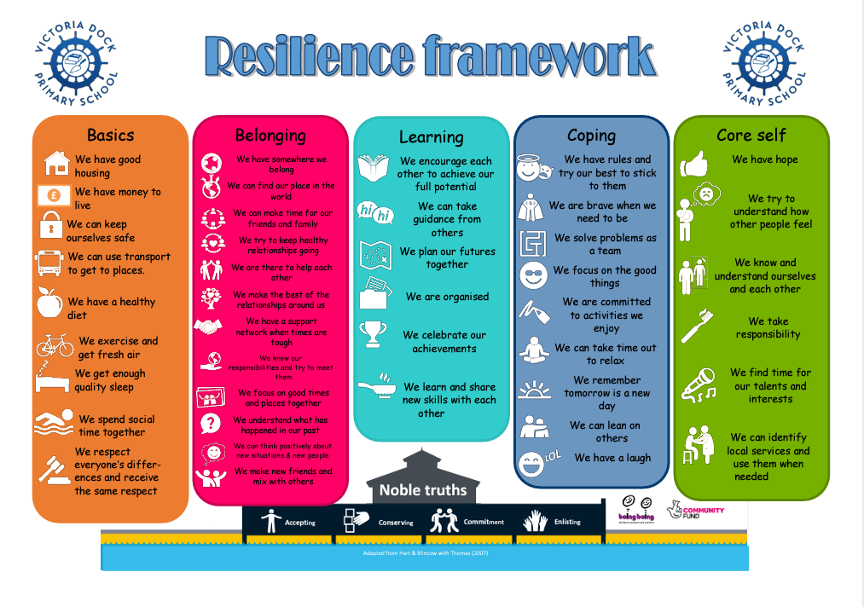

2 – Useful links and information

Children's mental health - Every Mind Matters - NHS (www.nhs.uk)

How to support your child's mental health – Place2Be

Parents Mental Health Support | Advice for Your Child | YoungMinds

MindEd For Families

Supporting bereaved children and young people | Child Bereavement UK

Grief support for young people | Winston's Wish (winstonswish.org)

