## **2zI8iP3eyR**

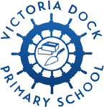

**Victoria Dock Primary**

**School Improvement Plan 2023-24**

**TRUST OBJECTIVES**

* All pupils, regardless of starting point, will meet their full potential
* All schools will offer a broad, exciting and engaging curriculum that creates a love of lifelong learning
* Every pupil will be given opportunities to develop socially and emotionally to become confident, resilient learners
* The achievement gap between disadvantaged and non-disadvantaged pupils will be closed
* Recruit and retain excellent staff providing high quality professional development
* Best value will be achieved through robust, centralised services to benefit all

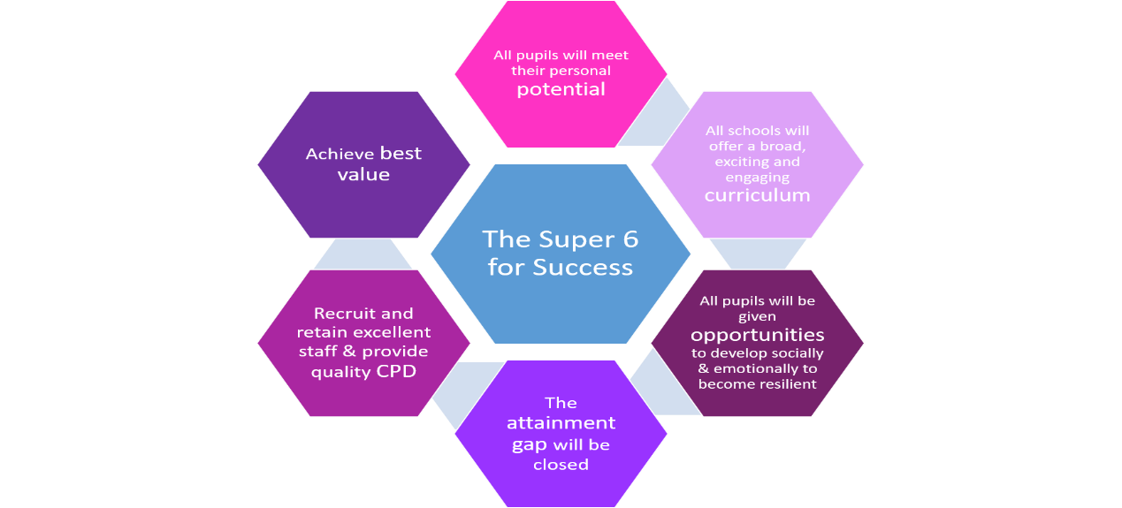

**Link to Trust Strategic Plan Priorities:**

To develop the Constellation Trust’s Strategy to continue to provide effective school improvement

**Overarching Priorities 2023 – 24: The Big Three**

1. Ensure consistently strong teaching leads to high quality outcomes for all.
2. Further refine the curriculum to ensure children learn and remember the core knowledge they need.
3. Effectively meet the needs of every pupil with SEND.