VICTORIA DOCK PRIMARY SCHOOL

FIRST AID POLICY

Working together for your children

Date Written - January 2020
To Be Reviewed: January 2024

To be read in conjunction with:
Child Protection Policy; Health and Safety Policy; Special Educational Needs Policy; Accessibility Policy; Asthma Policy, Intimate Care Policy; Complaints Procedure; Educational Visits; Supporting Children with Medical Needs and Whistle Blowing Policy.

Safeguarding Team
Headteacher | Antonia Saunders
Designated Safeguarding Lead | N Leach
Deputy Safeguarding Lead | L Taylor
E-Safety Lead | L Crooks
Designated Governor for Child Protection and Safeguarding | H Bowers
Behaviour Lead | Louise Taylor
SENCO | Louise Taylor
First Aid Leader | Julie Galloway

INTRODUCTION
First aid is the provision of initial care for an illness or injury. It is usually performed by a non-expert person to a sick or injured person until definitive medical treatment can be accessed. Certain self-limiting illnesses or minor injuries may not require further medical care past the first aid intervention. It generally consists of a series of simple and in some cases, potentially life-saving techniques that an individual can be trained to perform with minimal equipment.
Aims
The aims of our first aid policy are to:
- Ensure the health and safety of all pupils, staff and visitors;
- Ensure staff are aware of their responsibilities with regards to health and safety;
- Provide a framework for responding to an incident and recording and reporting the outcomes.

First aid at Victoria Dock Primary will be carried out by a trained first aider. At the school, this will be between the hours of 8.00am and 3.45pm. Emergency first aid will be carried out at the scene of an incident, all injuries dealt with safely and professionally by the trained first aider.
First Aid Kits, equipment and facilities
First aid takes place by a trained First Aider. First aid kits will be used for day trips, sporting events and residentials. First aid kits will be checked when returned and stock checked monthly using a checklist method.
No medicinal substance or materials are permitted within a first-aid box. This includes items such as antiseptic sprays, lotions, suntan oil, etc.

Safeguarding/Child Protection
The trained First Aider may treat an injured pupil and have safeguarding concerns. Injuries relating to safeguarding issues will be treated immediately, and the safeguarding designated lead will be informed immediately. The school will follow its Child Protection Policy.

Information on students
All staff will be made aware of which pupils have access to asthma inhalers, EpiPens, injections, or similar medical equipment and for whom individual healthcare plans have been created. This is important in order that all staff are prepared to deal with medical emergencies relating to these conditions no matter where in school the pupil is.

Minor Accidents and Injuries
The adult in charge initially looks after the injured party. If deemed necessary a First Aider will tend to the pupil.
No medicines are administered, cuts are cleaned with water or sterile un-medicated wipes and bandages are applied if deemed appropriate.
The use of disposable plastic gloves is mandatory at all times.

Minor Cuts and Bruises
- In all cases of injury, it is understood that there is at least one adult present:
- A first aider should administer first aid if appropriate. If the first aider is not available, any member of staff may clean the wound.
- Class teacher is informed by the first aider.
- Teacher observation is maintained
- Parents must be informed by the class teacher, at the end of the school day.

Sprains/Bruises
- A first aider should administer first aid if appropriate. If the first aider is not available, any member of staff may implement the process of rest, ice, compress and elevate
- If in doubt, parent/s are contacted
- Teacher observation is maintained
- Parents must be informed by the class teacher, at the end of the school day.

Head Injuries
Accidents involving the pupil’s head can be problematic because the injury may not be evident and the effects only become noticeable after a period.

Where emergency treatment is not required, a standard incident slip will be completed and sent home to the child’s parent/carer. The first aider dealing with the bump to the head will ask office staff to call home as soon as possible to inform parents/carers.

More Serious Accidents and Injuries
Parents are immediately informed, particularly if there is a suspicion of broken bones/head or eye injuries. The pupil is kept under close observation until parents/carers arrive, with the emphasis on making the pupil as comfortable and as settled as possible.

Stings/Bites
If the case is serious parent/s are contacted – no stings should be removed.

Very Serious Injuries
In the event of a very serious injury, parents/carers are immediately contacted. If the considered opinion of the staff is that immediate professional help is required, an ambulance is called.
On rare occasions, staff may agree to take the child to Accident & Emergency
in a private car
• This must be done with the Head teachers consent
• This should be on a voluntary basis
• Only staff insured to cover such transportation will be used.
A second member of staff will be present to provide supervision for the injured pupil.

Every effort will be made to contact the pupil’s parents/carers to keep them informed of developing situations.

Very serious injuries are considered to be:
Severe Bleeding
Burns/Scalds Unconsciousness

Procedure in the event of an illness
If a pupil falls ill whilst at school they should immediately tell a member of staff who will assess the situation and decide the best course of action.

Appropriate first aid will be given if required, and parents/carers will be called to collect their child if they are too unwell to complete the rest of the school day. If a parent or carer is unable to get to the school to collect their child, the child will remain in school until they are able to get there at the end of the day or arrange for another family member or carer to collect them.

Procedure in the event of an accident or injury
In the case of an accident or injury, the member of staff in charge should be informed immediately. They will assess the situation and determine whether or not emergency services need to be called. A designated first aider should be called for as soon as possible and should be informed of the injury, even if their assistance is not required.

First aiders should be called if the designated first aider is unavailable for any reason. First aiders are not paramedics, and if the first aider feels they cannot adequately deal with the injury then they should arrange for access to appropriate medical care immediately.

Emergency services

An ambulance should always be called by staff in the following circumstances:
- a significant head injury
- fitting, unconsciousness, or concussion
- difficulty in breathing and/or chest pains
- a severe allergic reaction
- a severe loss of blood
- severe burns or scalds
- the possibility of a serious fracture
- in the event that the first aider does not consider that they can adequately deal with the presenting condition by the administration of first aid, or if they are unsure of the correct treatment.

If an ambulance is called, the member of staff in charge should ensure that access to the school site is unrestricted and that the pupil can be easily accessed by emergency services when they arrive.

Pupils who are taken to hospital in an ambulance will be accompanied by a member of staff unless parents/carers are able to reach the school site in time to go with their child themselves. Ambulances will not be delayed for waiting for parents to arrive at the school. Parents will be informed immediately of any medical emergency and told which hospital to go to.

Recording and Documenting
All first aid will be documented both manually and electronically (SMART LOG). Parents will be informed of any injury or incident where this is judged to be necessary, based on the circumstances of the injury. If the first aider feels further medical assistance is required a parent/carer will be advised.

In accordance with DfEE guidance: A good practice guide – Guidance on First Aid for Schools, 2000 (amended 2014) it outlines the best practice for school’s recording system.
Paragraph 77
Schools should keep a record of any first aid treatment given by first aiders and appointed persons. This should include:
- the date, time and place of incident;
- the name (and class) of the injured or ill person;
- details of the injury/illness and what first aid was given;
- what happened to the person immediately afterwards (for example went home, resumed normal duties, went back to class, went to hospital)
- name and signature of the first aider or person dealing with the incident;
Paragraph 78
Information in the record book can:
- help the school identify accident trends and possible areas for improvement in the control of health and safety risks;
- be used for reference in future first-aid needs assessments;
- be helpful for insurance and investigative purposes.

Reporting to the Health and Safety Executive (HSE)
A record will be kept of any incident, which results in a reportable injury, disease, or dangerous occurrence, as defined in the RIDDOR 2013 legislation.

The Headteacher will report these to the HSE as soon as is reasonably practicable and in any event within 10 days of the incident.
Reportable injuries, diseases or dangerous occurrences include:
- death
- Specific injuries, which are:
- Fracture, other than to fingers, thumbs and toes
- Amputation
- Any injury likely to lead to permanent loss or sight or reduction in sight
- Any crush injury to the head or torso causing damage to the brain or internal organs
- Serious burns (including scalding)
- Any scalping required hospital treatment
- Any loss of consciousness caused by head injury or asphyxia
- Any other injury arising from working in an enclosed space which leads to hypothermia or heat-induced illness, or requires resuscitation or admittance to hospital for more than 24 hours
- Injuries where an employee is away from work or unable to perform their normal work duties for more than 7 consecutive days (not including the day of the incident)
- Where an accident leads to someone being taken to hospital
- Near-miss events that do not result in an injury, but could have done. Examples of near-miss events relevant to schools include, but are not limited to:
- The collapse or failure of load-bearing parts of lifts and lifting equipment
- The accidental release of a biological agent likely to cause severe human illness
- The accidental release or escape of any substance that may cause a serious injury or damage to health
- An electrical short circuit or overload causing a fire or explosion
Information on how to make a RIDDOR report is available here:
How to make a RIDDOR report, HSE
http://www.hse.gov.uk/riddor/report.htm

Senior leaders or Governors may decide to conduct internal investigations into less serious incidents to ensure that policy and procedure are being used correctly and effectively, and that future incidents of a similar nature can be avoided.

Training
All first aiders must have completed a training course, and must hold a valid certificate of competence to show this. The school will keep a register of all trained first aiders, what training they have received and when this is valid until.
Staff are encouraged to renew their first aid training when it is no longer valid.

APPENDIX I
APPENDIX II
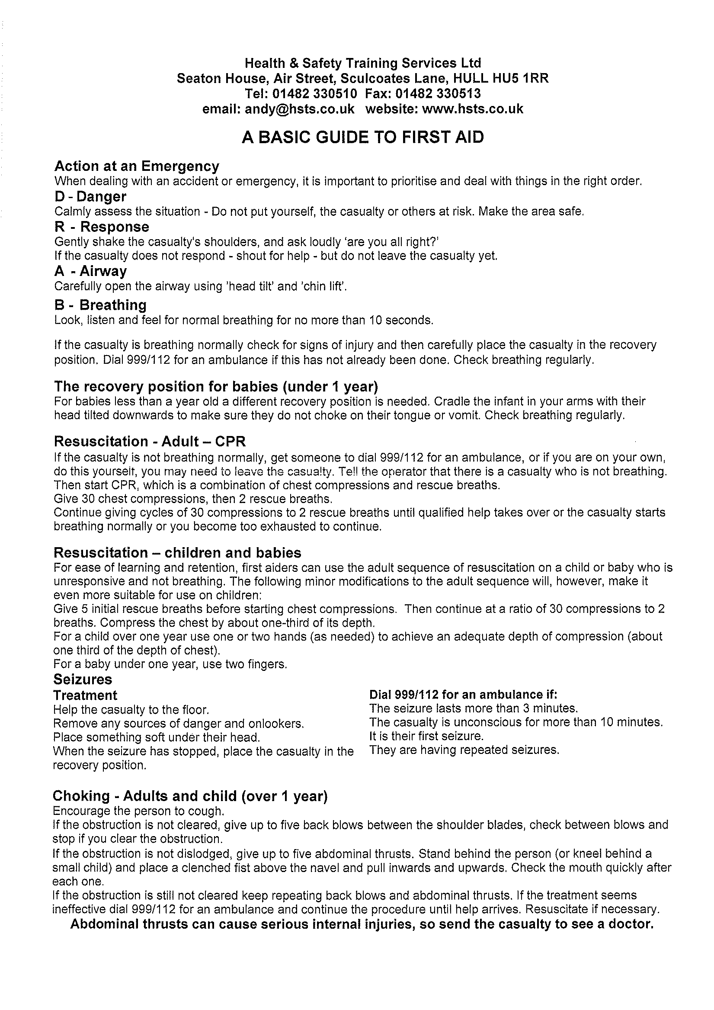

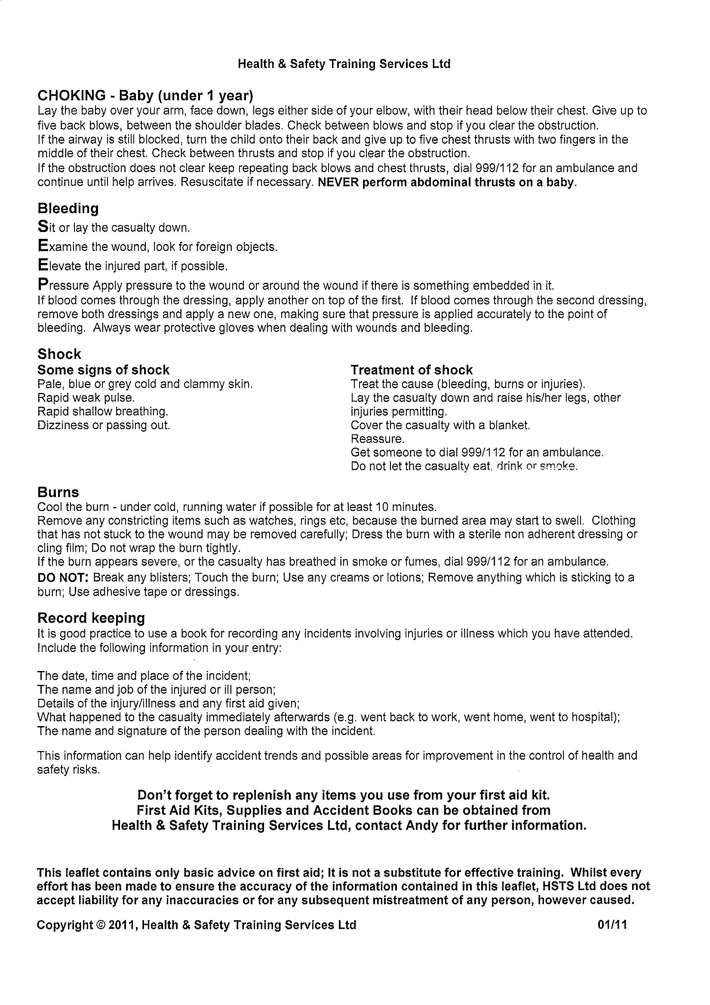

ADDENDUM
FIRST AID POLICY
COVID-19 – May 2020

Any first aiders who are unable to maintain a social distancing measure of 2m when attending a first aid incident should follow Government guidelines on usage of PPE:

When on duty they should ensure that they have immediate access to the minimum PPE; face mask, disposable gloves and plastic apron.

This is in addition to the normal First Aid equipment outlined in the School’s First Aid Policy.

First Aiders should make themselves familiar with the government guidance below in order to protect both themselves and others they are in contact with:

https://www.gov.uk/government/publications/novel-coronavirus-2019-ncov-interim-guidance-for-first-responders/interim-guidance-for-first-responders-and-others-in-close-contact-with-symptomatic-people-with-potential-2019-ncov

The relevant sections are:

7. What to do if you are required to come into close contact with someone as part of your first responder duties

7.1 Personal protective equipment (PPE)
Where it is not possible to maintain a 2 metre or more distance away from an individual, disposable gloves and a disposable plastic apron are recommended. Disposable gloves should be worn if physical contact is likely to be made with potentially contaminated areas or items.

The use of a fluid repellent surgical face mask is recommended and additional use of disposable eye protection (such as face visor or goggles) should be risk assessed when there is an anticipated risk of contamination with splashes, droplets of blood or body fluids.

When using a fluid repellent surgical face mask, you should mould the metal strap of the mask over the bridge of the nose and make sure the mask fits snugly under the chin, around or across any facial hair if present.

Clean your hands thoroughly with soap and water or alcohol sanitiser before putting on and after taking off PPE. In all circumstances where some form of PPE is used, the safe removal of the PPE is a critical consideration to avoid self-contamination.

Guidance on putting on and taking off PPE is available at https://assets.publishing.service.gov.uk/government/uploads/system/uploads/attachmentdata/file/877658/QuickguidetodonningdoffingstandardPPEhealthandsocialcare_poster.pdf. Use and dispose of all PPE according to the instructions and training provided by your employer or organisation.
7.2 Cardiopulmonary resuscitation
If you are required to perform cardiopulmonary resuscitation (CPR), you should conduct a risk assessment and adopt appropriate precautions for infection control.

In adults, it is recommended that you do not perform rescue breaths or mouth-to-mouth ventilation; perform chest compressions only. Compression-only CPR may be as effective as combined ventilation and compression in the first few minutes after non-asphyxial arrest (cardiac arrest not due to lack of oxygen).

Cardiac arrest in children is more likely to be caused by a respiratory problem (asphyxial arrest), therefore chest compressions alone are unlikely to be effective.

If a decision is made to perform mouth-to-mouth ventilation in asphyxial arrest, use a resuscitation face shield where available.

Should you have given mouth-to-mouth ventilation there are no additional actions to be taken other than to monitor yourself for symptoms of possible COVID-19 over the following 14 days. Should you develop such symptoms, please follow the advice on what to do on the NHS website

7.3 Providing assistance to unwell individuals
If you need to provide assistance to an individual who is symptomatic and may have COVID-19, wherever possible, place the person in a place away from others. If there is no physically separate room, ask others who are not involved in providing assistance to stay at least 2 metres away from the individual. If barriers or screens are available, these may be used.

7.4 Cleaning the area where assistance was provided
Cleaning will depend on where assistance was provided. It should follow the advice for cleaning in non-healthcare settings. Public areas where a symptomatic individual has passed through and spent minimal time in (such as corridors) but which are not visibly contaminated with body fluids can be cleaned in the usual way. However, all surfaces that a symptomatic individual has come into contact with must be cleaned and disinfected.

7.5 If there has been a blood or body-fluid spill
Keep people away from the area. Use a spill-kit if available, using the PPE in the kit or PPE provided by your employer/organisation and following the instructions provided with the spill-kit. If no spill-kit is available, place paper towels/roll onto the spill, and seek further advice from emergency services when they arrive.

7.6 Contacts of the person you have assisted
Advise anyone who had close contact with the individual that if they go on to develop symptoms of COVID-19 (a new continuous cough, fever or a loss of, or change in, normal sense of taste or smell), they should follow the advice on what to do on the NHS website.

