Victoria Dock Primary School Handwriting Policy

Spring 2023

Handwriting at Victoria Dock Primary School

Intent
Handwriting is a skill, which, like reading and spelling, affects written communication across the curriculum. Children must be able to write with ease, speed and legibility. Cursive handwriting teaches pupils to join letters and words as a series of flowing movements and patterns. The development of this fluid style when mastered allows children to apply their energy into the content of their writing as opposed to the formation of the letters themselves. Handwriting skills are taught regularly and systematically throughout the school.

At Victoria Dock Primary School our aims in teaching handwriting are:
- To enable children to write in a consistent, well presented and legible format
- To have a consistent approach across Foundation Stage, Key Stage 1 and 2 when teaching handwriting
- To ensure the skills taught at Key Stage 1 continue to develop throughout Key Stage 2
- To make sure all children know the difference between lower and upper case letters
- When children can form letters of the correct size and shape, they will be taught a cursive writing style which will continue throughout Key Stage 2
- To adopt a consistent approach towards handwriting by all adults when writing in children’s books, on the whiteboard or on displays / resources

Implementation
Children at Victoria Dock Primary School will be taught to:
- Write from left to right and from top to bottom of the page
- Form regularly sized and shaped letters
- Use regular spacing between letters and words
- When the children are ready, start and finish letters correctly in a cursive style
- Take a pride in their written work and the overall presentation

Sometimes children may have a barrier to learning which can impact on their ability to communicate their ideas and knowledge through writing in line with their peers.
In this case the school would follow the SEND identification process, as stated in the SEND policy, and where appropriate refer to specialist services for advice.

Equipment
Children will use line sizes appropriate to their stage in writing. During handwriting sessions, specific handwriting paper may be used. Children in Key Stage 1 (and Key Stage 2 where necessary) will use appropriately lined books when writing in English and guided reading, demonstrating skills are transferable and that the same expectation of handwriting in set across all writing.
Children should use a sharp HB pencil for all handwriting. In some cases, depending on the specific needs of the individual, children may use pencil grips or pens with a specific grip.

Impact
Handwriting is a skill which affects written communication across the curriculum. Our aim is that children are able to write with ease, speed and legibility. By Key Stage 2, children will use cursive handwriting using flowing movements and patterns. This handwriting should be demonstrated in all writing across the curriculum. Writing should be fluid in style to allow children to apply their energy into the content of their writing as opposed to the formation of the letters themselves.
Letter Phrases

As soon as children start with us in EYFS we begin teaching letter formation using the Read, Write, Inc. phrases.
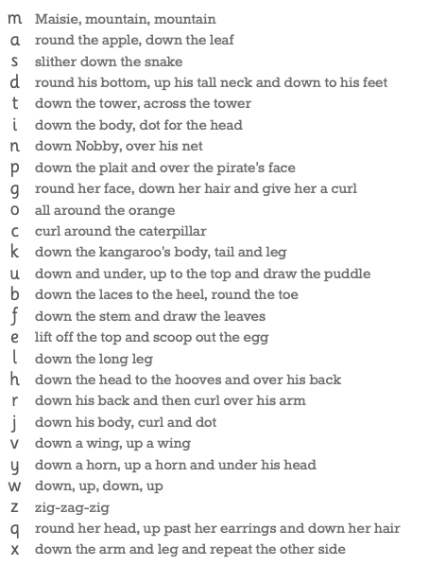

We teach the children the correct sitting position and tripod grip for writing.
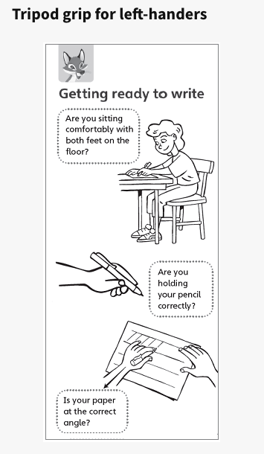 | 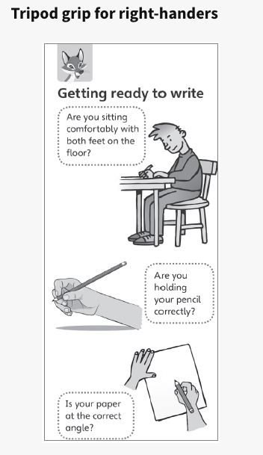
The Letter Families

We explicitly teach handwriting in letter families in year 1.
These are letters that are formed in similar ways.
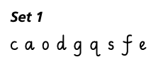 | 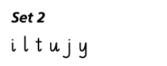
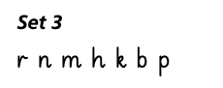 | 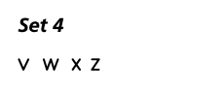
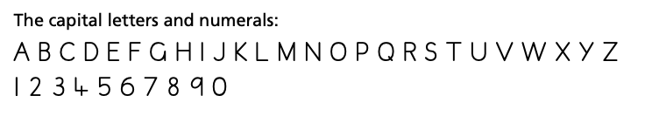

Joining Groups

The joining groups divide the letters accoridng to how they join to other groups. We encourage children to slant their letters at the beginning of year 2 anf then we begin teaching the joins later in year 2, when the children have secured their letter formation.

Thirteen letters with exit flicks plus s.
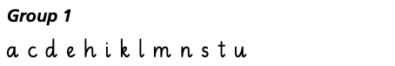
Nineteen letters which start at the top of the x-height.
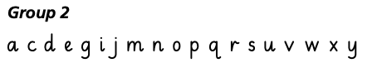
Six letters which start at the top of the ascender.
Five letters which finish at the top of the x-height.
Eight letters after which no join is made. Joins are not made to or from the letter z.
