Year 4/5 Homework 5.3.20
English.
Review/ summarize in a paragraph a narrative story of your choice.

Maths
Year 4- Please continue to use Timetables Rockstars to practice your timetables. Teachers will be monitoring progress ahead of the Year 4 statutory times table test in the summer term.

Year 5-
Order these fractions from smallest to largest. Remember all the fractions need to the same denominator!
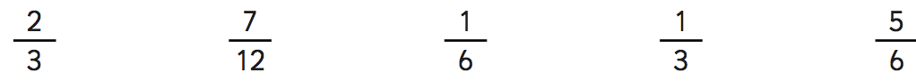
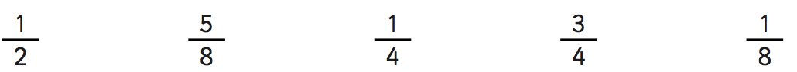
Order these fractions from largest to smallest. Remember all the fractions need to the same denominator!

Spellings
Year 4 Spellings | Year 5 Spellings
Continue | Rhythm
Decide | Sacrifice
Different | Shoulder
Experience | Secretary
Famous | Symbol
Experiment | Suggest
Grammar | Temperature
Disappear | Twelfth
History | Vegetable
Medicine | Vehicle
Note- Please can children start collecting 500ml drinks bottles in preparation for a DT project. Thank you, Miss Joyce, Mr McDougall and Mrs Birch

