Year 4/5 Homework 27.2.20

English.
Add a subordinate clause to the sentences below.
- The children went to eat their dinners in the hall.
- The boys and girls had to put their coats on in order to be able go outside.
- The year 5 worked looked beautiful on the wall.
- The boy carried on eating his sweets from the packet.
- Some of the classrooms were left in an absolute mess at the end of the day.
Maths
Year 4- Please continue to use Timetables Rockstars to practice your timetables. Teachers will be monitoring progress ahead of the Year 4 statutory times table test in the summer term.

Year 5-
Convert these improper fractions to a mixed number.
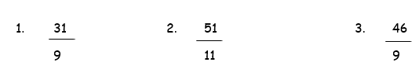
Convert these mixed numbers to improper fractions.
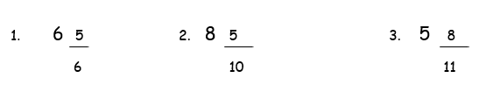

Spellings
Year 4 Spellings | Year 5 Spellings
appear | appreciate
caught | communicate
different | desperate
extreme | exaggerate
heard | harass
learn | lightning
occasion | parliament
possess | recommend
recent | sincerely
suppose | variety

