Year 4/5 Homework 14.2.20

English.
Apostrophes.
Rewrite the sentences with the correct shortened version of the word.
- That car is not very fast.
- I have a lot of toys.
- She did not eat the cake.
- He could have brought his trainers with him.
- You will see the dentist next week.

Maths
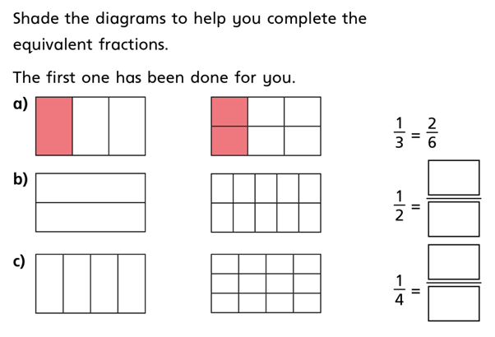

Spellings
Year 4 Spellings | Year 5 Spellings
You’ll | Cough
Boy’s | Thought
Children’s | Plough
Potato’s | Rough
Lady’s | Though
Don’t | Enough
Child’s | Through
I’ve | Fought
Can’t | Dough
Lorry’s | Tough

